Love vs. Hate: Tweets Toward Others

# Introduction

For this analysis, we sought to understand “love and hate” on Twitter. Specifically, we focused on tweets that included the word love or hate and whether those tweets tended to be directed toward ‘people’. That is, we wanted to know if there is a difference in the number of tweets directed toward people when users were tweeting about love or hate. Because of the variety of tweets, we decided early on to narrow our focus to tweets that involved personal pronouns as a type of proxy for a tweet being directed toward a person or group of people (like you or someone) and not toward a thing or event (like shoes or a sports game).

We believe there are many audiences that could benefit from more understanding more about whether a tweet about love or hate is directed toward a person or not. For example, a personal image management company might encourage its followers to tweet their love for a client, or hate toward their client’s nemesis. A parent might be interested in how prevalent tweets are when they express hate for another person. Understanding if there is a difference between how love and hate is tweeted will also help to advance further questions about the topic.

# Data Collection and Analysis

To perform the analysis, we collected data using the Twitter REST API on 11/28/2018. Two sets of data for 10,000 tweets were collected: one containing the word “hate”, another containing the word “love”. We then flagged instances where tweets contained personal pronouns after the word love/hate such as, “love you, love her, love everyone, hate them, hate someone, hate everybody, etc.” We also ensured we excluded non-personal extensions (likely directed toward objects belonging to people) of words such as you or everyone, such as “love your” or “hate everyone’ “. While we did look at data regarding ‘mentions’ such as @John, we did not find that it changed the outcome of our analysis.

We performed a Two-sample Test for a Difference of Proportions to determine whether there was a difference between our two samples of tweets.

# Results/Conclusion

We found that there is enough evidence to conclude there is a statistical difference between love and hate tweets. That is, when looking at love tweets vs. hate tweets for usage of personal pronouns described previously, we indeed see a difference in proportions. As shown in the number of tweets in Figure 1, our sample of love tweets use pronouns 15.1% of the time. As shown in Figure 2, 12.5% of the hate tweets use pronouns. Our statistical testing determines we can generalize there is a large enough difference in whether a tweet is directed toward a person between all tweets containing either ‘love’ or ‘hate’ to extrapolate to the larger population of tweets on Twitter, with confidence.

In conclusion, we know that tweets about love and hate tend to differ when it comes to whether or not they are directed toward people.

*FIGURE 1: LOVE TWEETS*

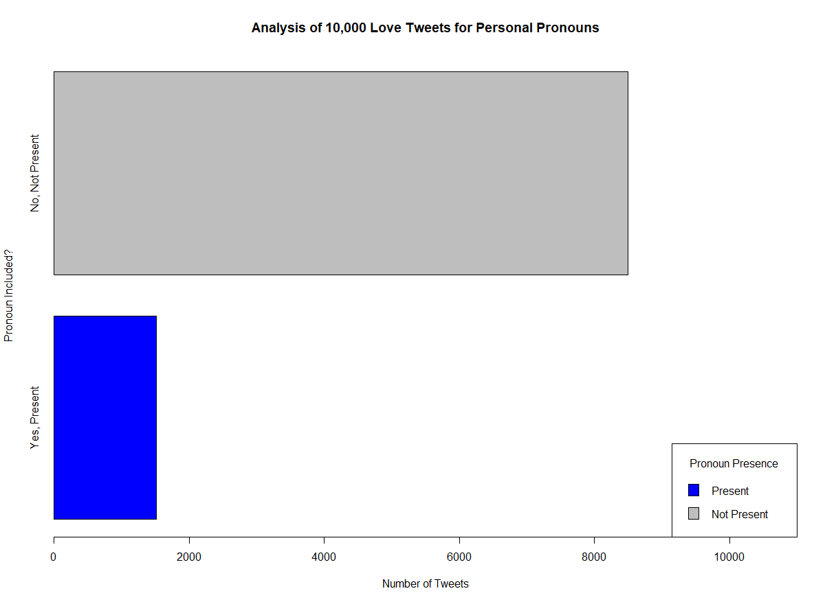

*FIGURE 2: HATE TWEETS*

